Resposta da prova de matemática:

1)



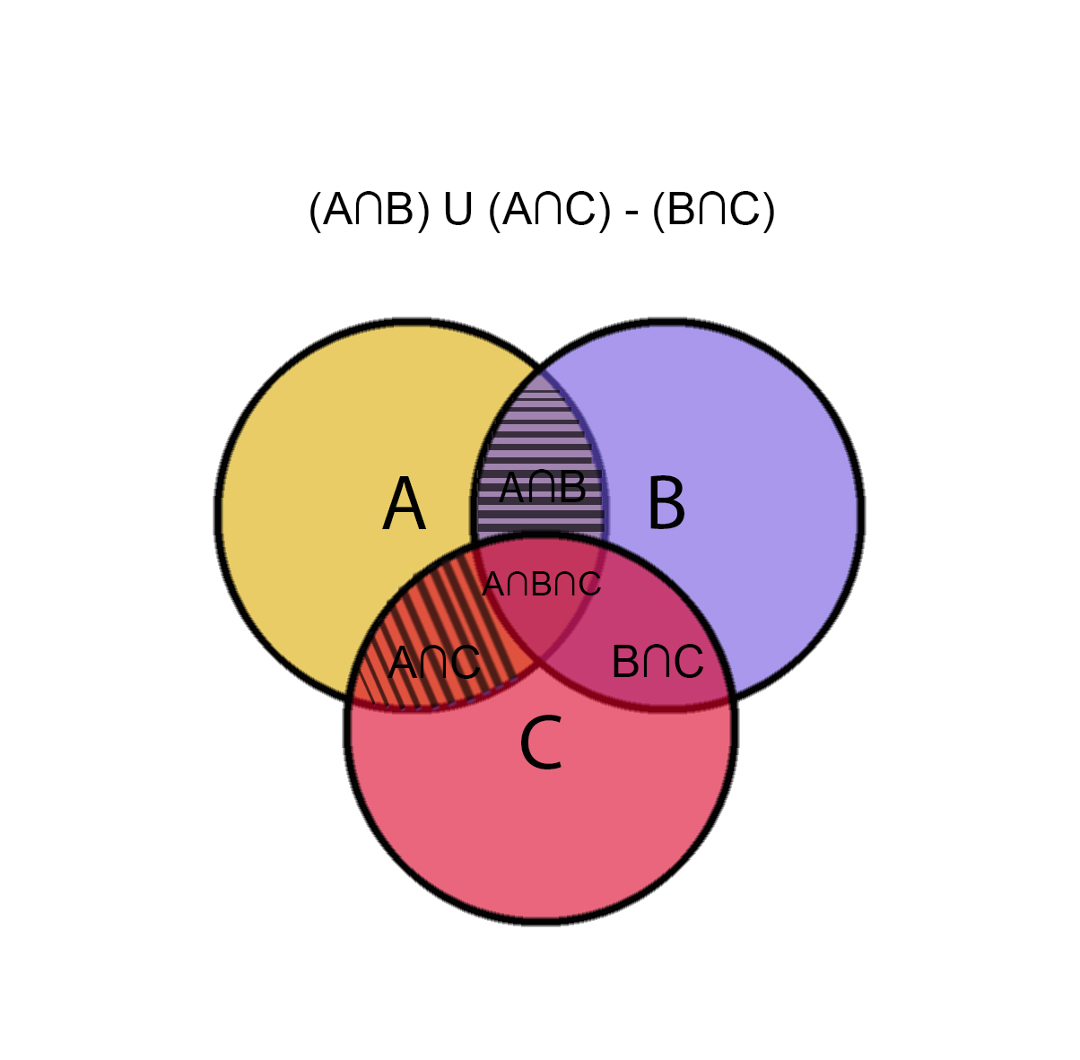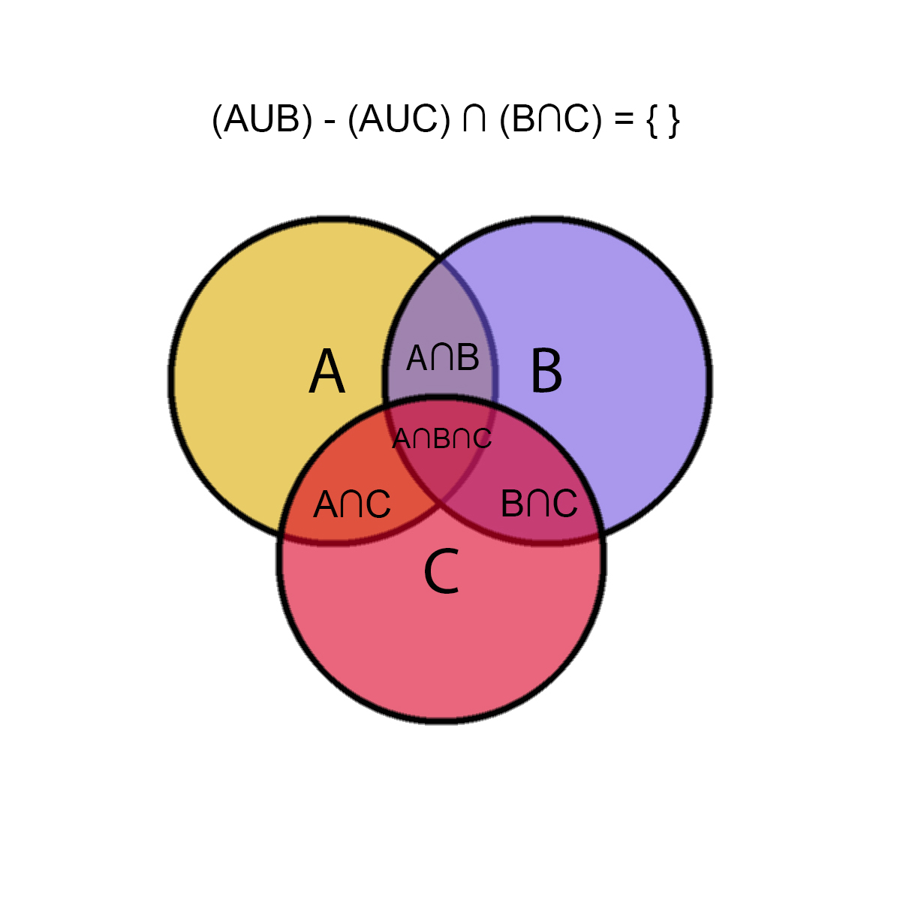

2)

A) A U C = {1,2,3,5,7,9}

B) B U C = {1,2,3,4,5,6,8}

C) A U B = {1,2,3,4,5,6,7,8,9}

D) A ∩ C = {1,3,5}

E) A – C = A = {7,9}

F) C – A = C = {2}

G) A – B = A = {1,3,5,7,9}

H) B – A = B = {2,4,6,8}

I) A U B = {1,2,3,4,5,6,7,8,9}

J) A – B + {1,3,5,7,9}

K) A ∩ B = { }

L) A – C = A = {7,9}

M) (A – B) ∩ C = {1,3,5,7,9} ∩ {1,2,3,5} = {1,3,5}

N) (A – C) U (B – C) = A – C = {7,9} U B – C = {4,6,8} = {4,6,7,8,9}